Building Bridges: Syd Harvey is a firm believer in God's design for healthy families to strengthen communities. Our diverse communities bring diverse challenges and every individual has a unique part to play in being an agent of change. Whether you are searching to get involved in something new or need encouragement for the journey you are on, Syd's insights and enthusiasm will inspire and challenge you to greater heights and depths of involvement with vulnerable children and families.
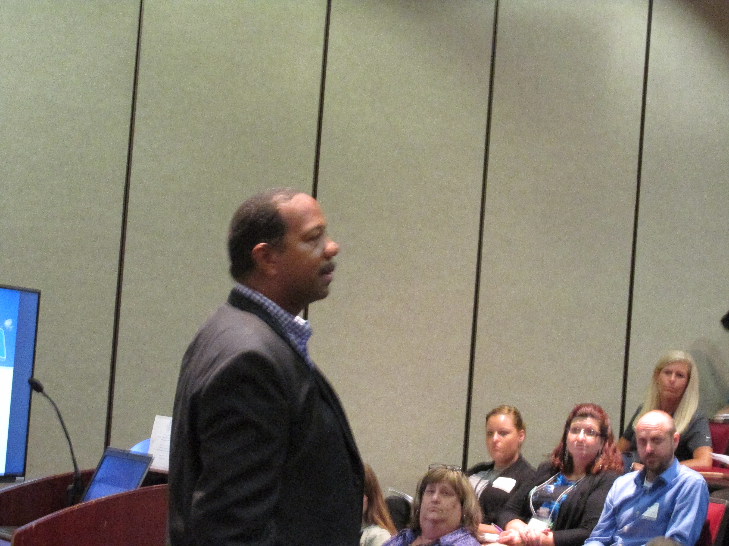

Sydeon Harvey is currently the Director of Operations at Family Outreach Center. He also is a trainer and strategic planner with over 20 years of experience in the area of diversity/inclusion work and community building. He has led trainings for all different age groups, churches, schools, community groups, medical staff, mental health staff, and businesses inside and outside our state on diversity, as well as been a speaker at national conferences. His workshops are full of passion and are led in a way that encourages and challenges everyone to feel safe and empowered. His personal mission in life is to be agent of healing and change.

